

**Department of Electrical and Computer Engineering**

**North South University**

**Spring 2020**

**Project Report**

**Course code: CSE482**

**Section: 03**

**Course name: Internet and Web Technology**

**Submitted To: Shamim Al Mamun(SAM3)**

**Project Title:**

# Superman.com (Online Grocery Shop)

**Submitted By:**

|  |  |
| --- | --- |
| Name | ID |
| Sakif Ahmmed | 1610321042 |
| Md Tanvir hassan Bhuiyan | 1610930042 |
| Md Siam | 1612544042 |
| Nusrat jahan | 1612265042 |
| Khadizatul kubra | 1620070042 |
| Md Sakhawat Hossain | 1512017042 |
| Mohammad Munem Shahriar Hossain | 1421206042 |

# ABSTRACT

In this modern age, people want to get everything easily with less amount of time. It’s extremely important to be able to respond to client needs in the most effective and timely manner. Online Shopping is an E-commerce web application, which retails various grocery shops. This project allows viewing various products available enables registered users to purchase desired products instantly using PayPal payment processor (Instant Pay) and also can place order by using Cash on Delivery (Pay Later) option. This project provides an easy access to Administrators and Managers to view orders placed using Pay Later and Instant Pay options. In order to develop an e-commerce website, a number of Technologies must be studied and understood.

# ACKNOWLEDGEMENTS

To complete this project I have been fortunate to have help, support and encouragement from many people. I would like to acknowledge them for their cooperation.

First and foremost deeply thankful to Professor Dr. Shamim -Al-Mamun Sir, for his wonderful guidance during this project work in field of internet and web technology.

We are also thankful for her continuous feedback and encouragement throughout this project work. His broad knowledge and hardworking attitude has left us with very deep impressions and they will greatly benefit us throughout my life.

Also, we would like to thank our project lab officer Zarin Tarannum Hoque for her support throughout this project work.

# INTRODUCTION:

E-commerce website is the most useful website in today’s world because anyone can buy anything from home without any struggle. More and more business houses are implementing web sites providing functionality for performing commercial transactions over the web. It is reasonable to say that the process of shopping on the web is becoming commonplace. The objective of this project is to develop a general purpose e-commerce store where product like grocery things can be bought from the comfort of home through the Internet.

An online store is a virtual store on the Internet where customers can browse the catalog and select products of interest. The selected items may be collected in a shopping cart. At checkout time, the items in the shopping cart will be presented as an order. At that time, more information will be needed to complete the transaction. Usually, the customer will be asked to fill or select a billing address, a shipping address, a shipping option, and payment information such as credit card number. An e-mail notification is sent to the customer as soon as the order is placed.

# Project Problem:

Runa had two children one is 7 years and other is 3 years old. She has no helping hand in her home but relatives inform that they will visit her house today. Runa told that they can come to visit her house .But problems are many .the gatekeeper won’t go outside because there will be a risky situation. Runa is very worried and thinking her husband office is at Uttara and her home is at Paltan. So she has no chance to have grocery in a very short time. So she sent her cousin’s son and her cousin’s son replied that there is not enough vegetables in that store. All items are not available. If Runa said him to go to the fixed shop, he didn’t go that shop and brought unnecessary grocery to Runa. So how Runa can get all her listed grocery things in a very short time?

Remember there is no one to helpher.

# Solution:

We think we can solve Runa’s problem by making web base software where people will be able to hire workers for their any kind of daily work. The aim of this project is to provide worker and the worker will help you all possible way in shortest amount of time. The users of this software will be able to see their workers through their phone via Google map. This software specially will help the people of Dhaka to do their daily household works easily.

1) Users can sign in or log in our website to order their necessary product.

2) Users can see which workers performance is good so they can choose worker according to their rating.

3) User can see where the worker is located via Google map

4) We have our own grocery shop where all the items are available, so user can relax to find their necessary product

5) Price will be cheap and affordable for the customer, so there is no chance to lose anything

6) User can select, can see price details, product details, everything in our website

7) After choosing product they can order through their mail in our website

8) They can choose cash on delivery or Bkash in their payment method

9) User can see how many times will take to get their desired product

10) Finally they can rate the worker performance and our whole system.

# Overall solution:

* Any member can register and view available products.
* Only registered member can purchase multiple products regardless of quantity
* Contact us page is available to contact Admin for queries.
* There are three roles available: Visitor, User and Admin.
* Visitor can view available products
* User can view and purchase products
* An Admin has some extra privilege including all privilege of visitor and user
* Admin can add products, edit product information and add/remove product.
* Admin can add user, edit user information and can remove user
* Admin can ship order to user based on order placed by sending confirmation mail.

## USER STORY:

### Use case 1:

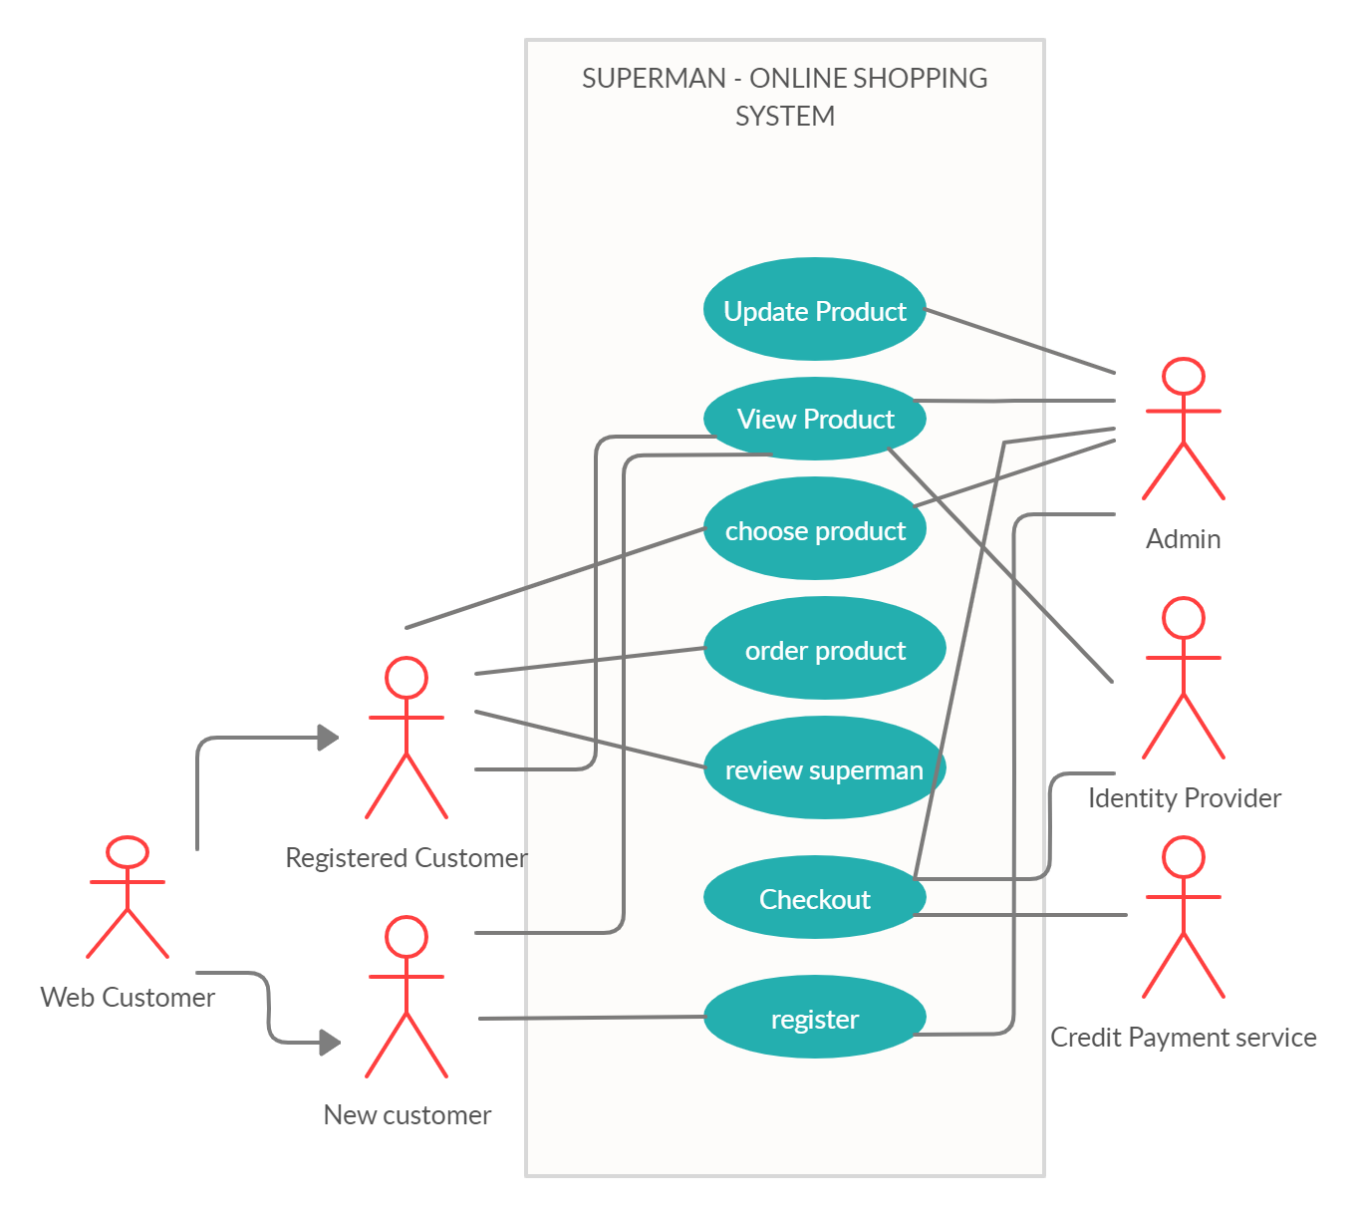

## ER Diagram:

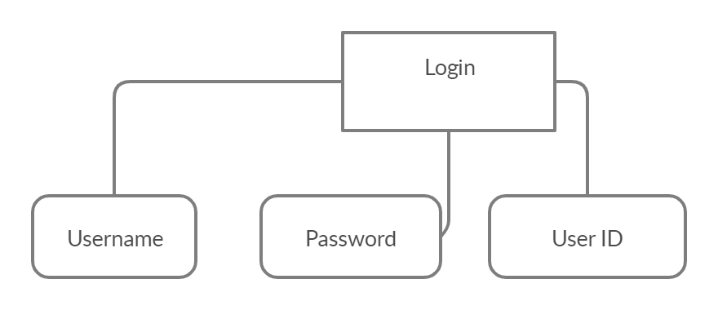

Figure: User Login Flowchart

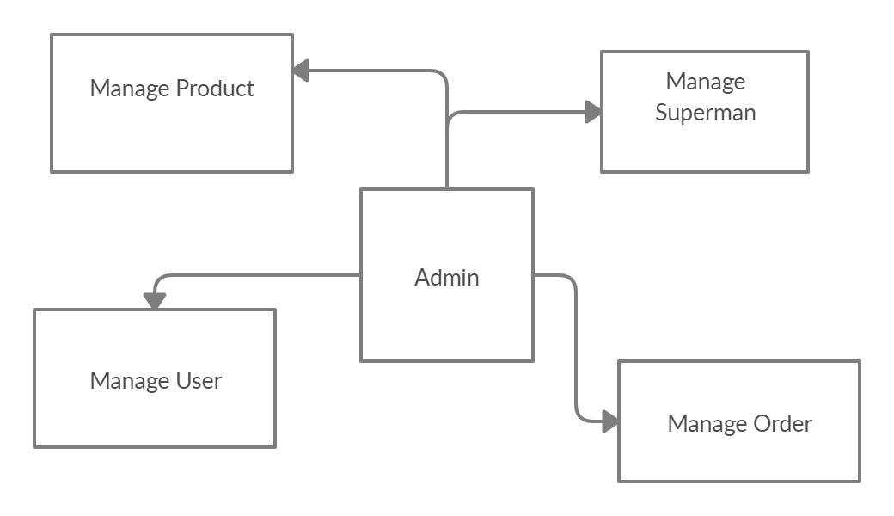

Figure: Admin Flowchart

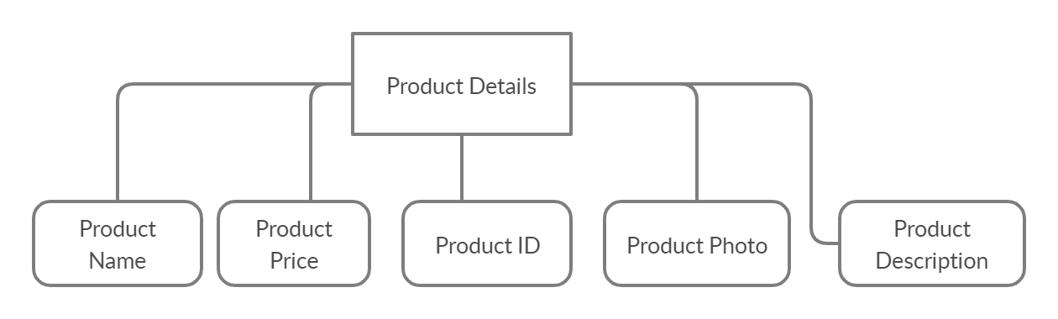

Figure: Product Details Diagram

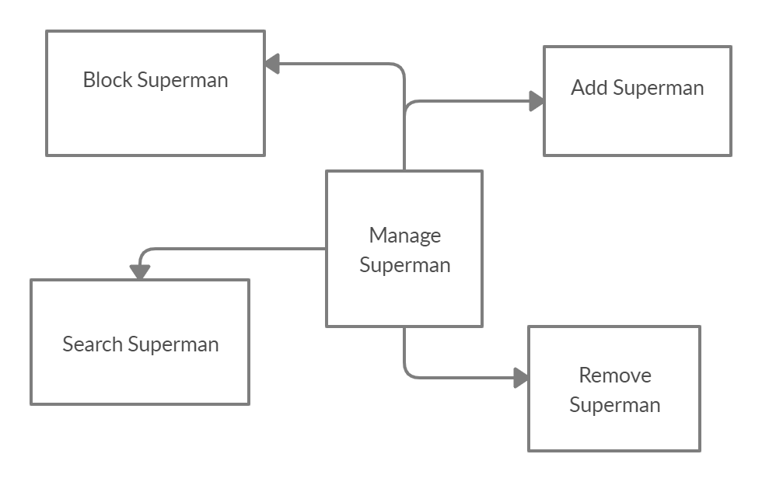

Figure: Moderator Flowchart

Add Moderator: Only admin is having the privilege to add a moderator. A moderator can be considered as a staff who manages the orders or owner of a group of products.

Block Moderator: Admin can restrict a moderator from managing the orders by blocking them. Admin can unblock a blocked user if needed.

Remove Moderator: Admin has privilege to delete a moderator who was added.

Search moderator: All existing moderators can be viewed by the administrator as a list. If there is number of moderators and admin need to find one of them, the admin can search for a moderator by name.

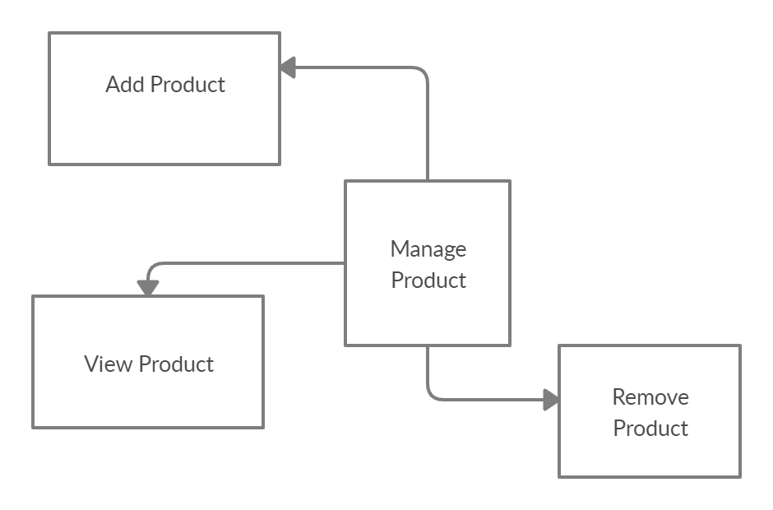

Figure: Manage Product Flowchart

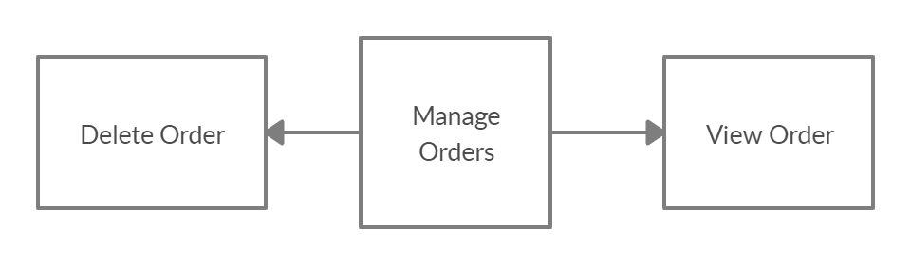 Figure: Manage Order Flowchart

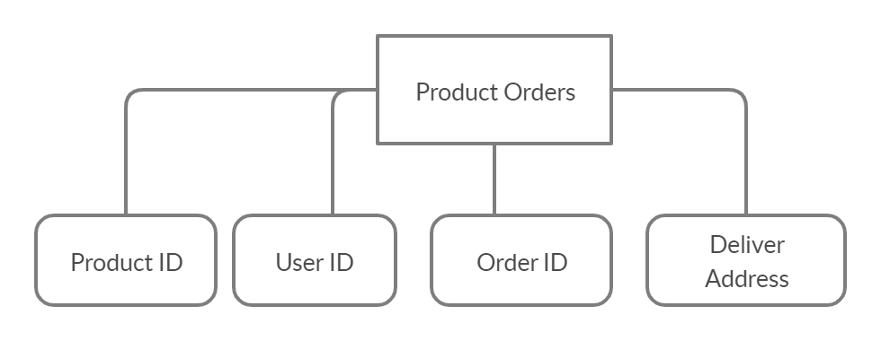 Figure: Product Orders Diagram

### Complete Diagram:

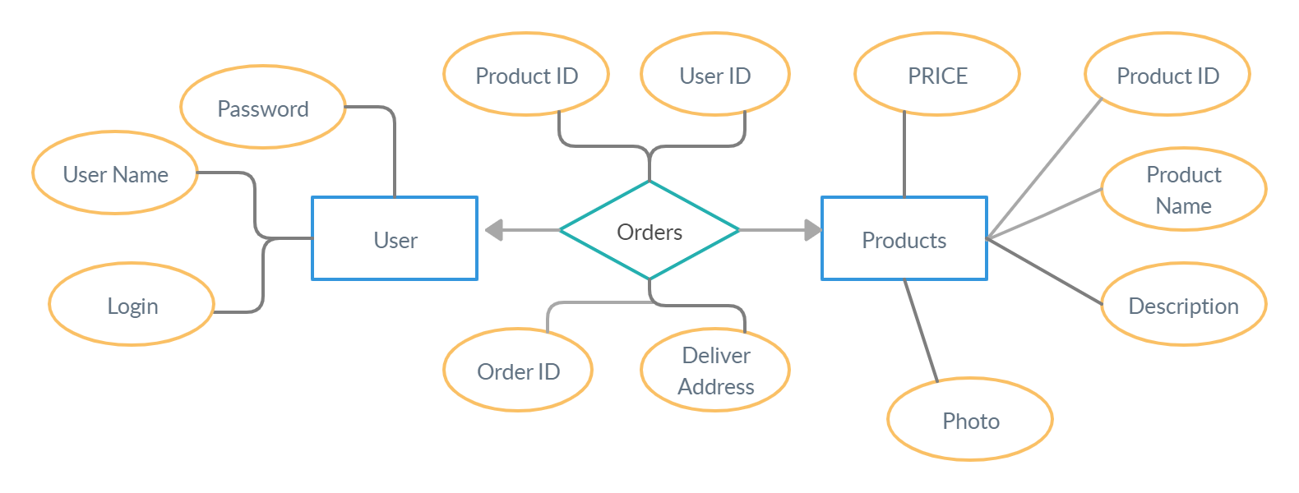

## Solution Description:

User must log in or sign up for online shopping from our superman.com website by using their email and phone number. Unregistered people can sign up/ register by using their mobile or email address and it’s easy to signup/log in our web page. Only Admin will have access to modify roles . Everyone can view Online shopping portal and available products.

# Log In/Sign Up page:

The first page of our website will be this log in /sign up page. Everyone can register or log in our website. Admin will preview this online member. Every customer should have an account to buy product from our website. So that we can find customer information like customer address phone number to deliver their product.

# Homepage:

In our superman.com website, the homepage will consist of screen of every page. On the navigation bar there will be every page link where we can go from this home page. At the end of every page we have added custom.

# About Us Page:

In this page we have added customer review and our system analyst speech. Subscription for our newsletter there will be an option for signing up with email address. This page actually describes about our developer or owner information and also about this website in detail.

# Contact us page:

In this page we have added location map and customer information form. Customer can send direct message to us and we can reply to them by sing their email address.

# Product cart page:

You can see your buying product details and price and total amount of your bill .We have added coupon code. By using this code customer can get discount to buy anything from our website.

# Checkout page:

In this page we can see customer information .customer can shift to their different address .Customer can choose payment option. Direct bank transfer, check payment, cash on delivery , paypal.

# Blog page:

In this page we have added where best foods are available in our country. This page also includes recent vegetables price news in Bangladesh. There are many articles about our product details.

# Wish List page:

You can add in your cart anytime when the product is available in our website. You can see product quantity and price details.

You can see single product details with product description in another page. Total price list which you have added in your cart.

# Development Plan:

Anyone can view Online Grocery Shopping portal SUPERMAN and available products, but every user must login by his/her Username and password in order to purchase or order products. Unregistered members can register by navigating to registration page. Only Admin will have access to modify roles, by default developer can only be an ‘Admin’.

HOMEPAGE:

The Home Screen will consist of screen where one can browse through the products which we have on our website.



Grocery Product PAGE:

This page consists of product details. This page appears same for both visitors and users.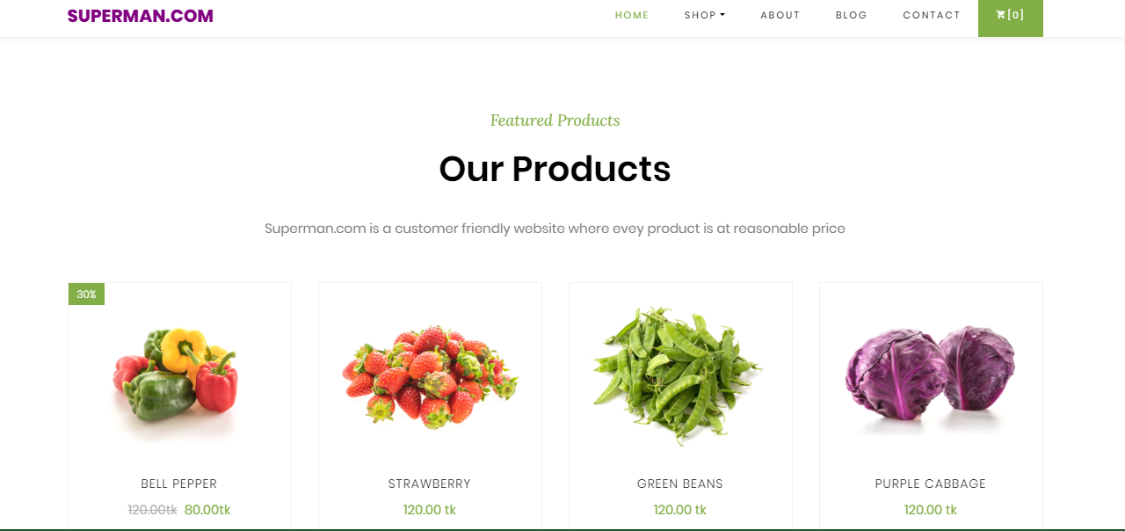

## Single Product Description:

User can view every single product with quantity and price.

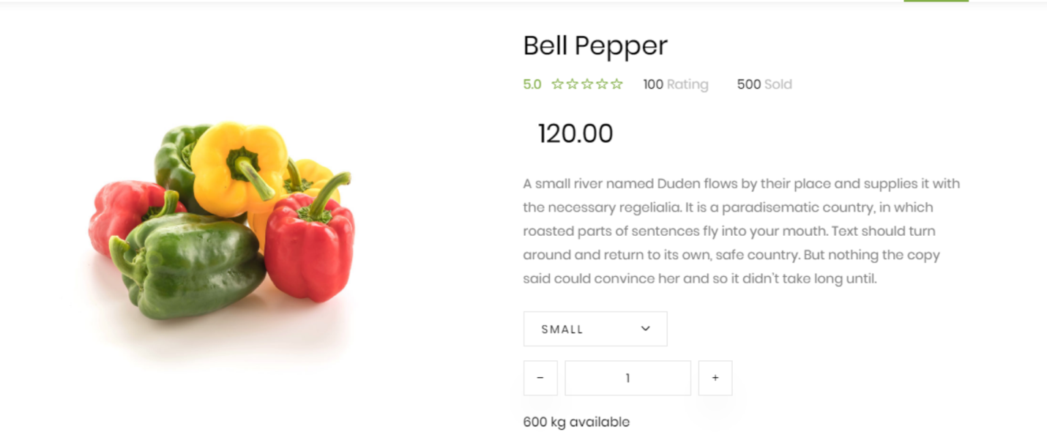

Order Us Page:

Registered users can order desired products from here.

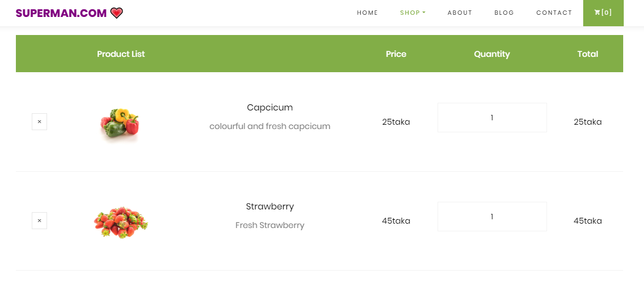

## Contact Us Page:

Visitors and Registered users can contact website owners or administrators from here.

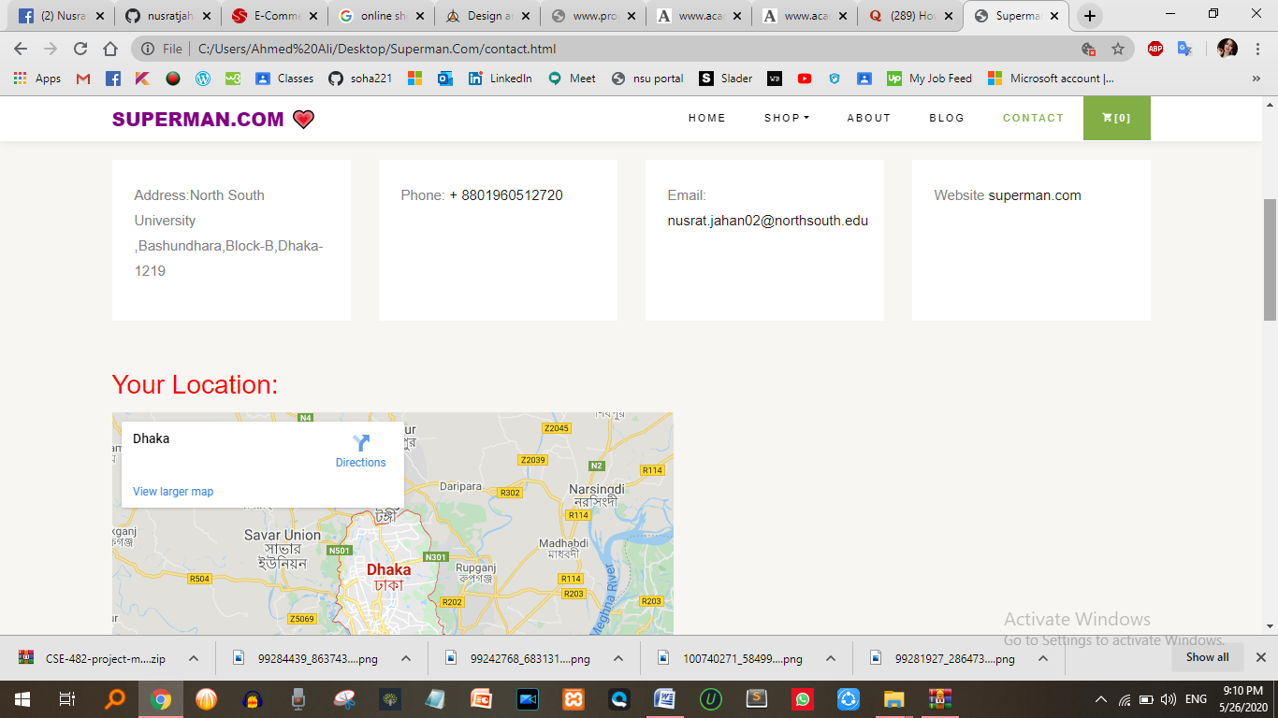

## MAP NAVIGATION:

One can search and find our location through google map. 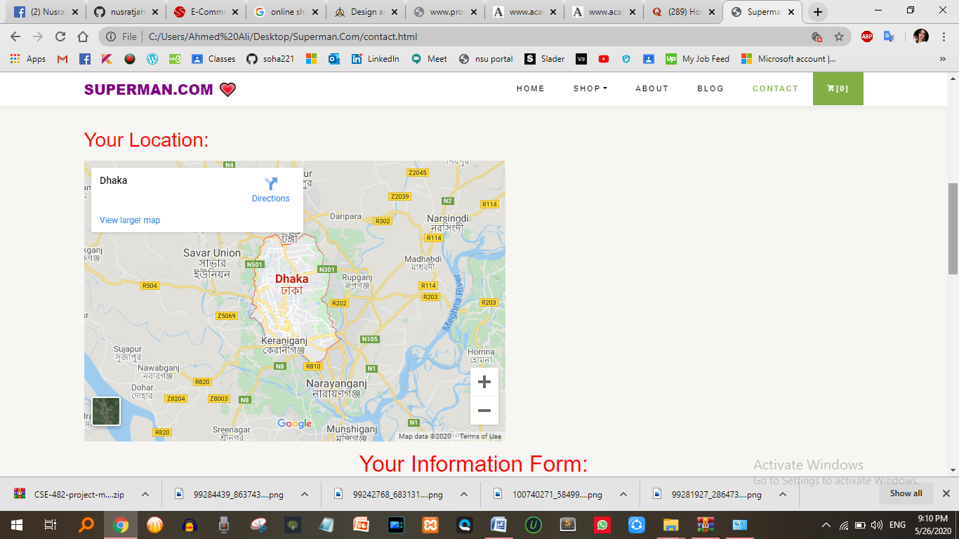

ABOUT US PAGE: This page describes about website and owners.

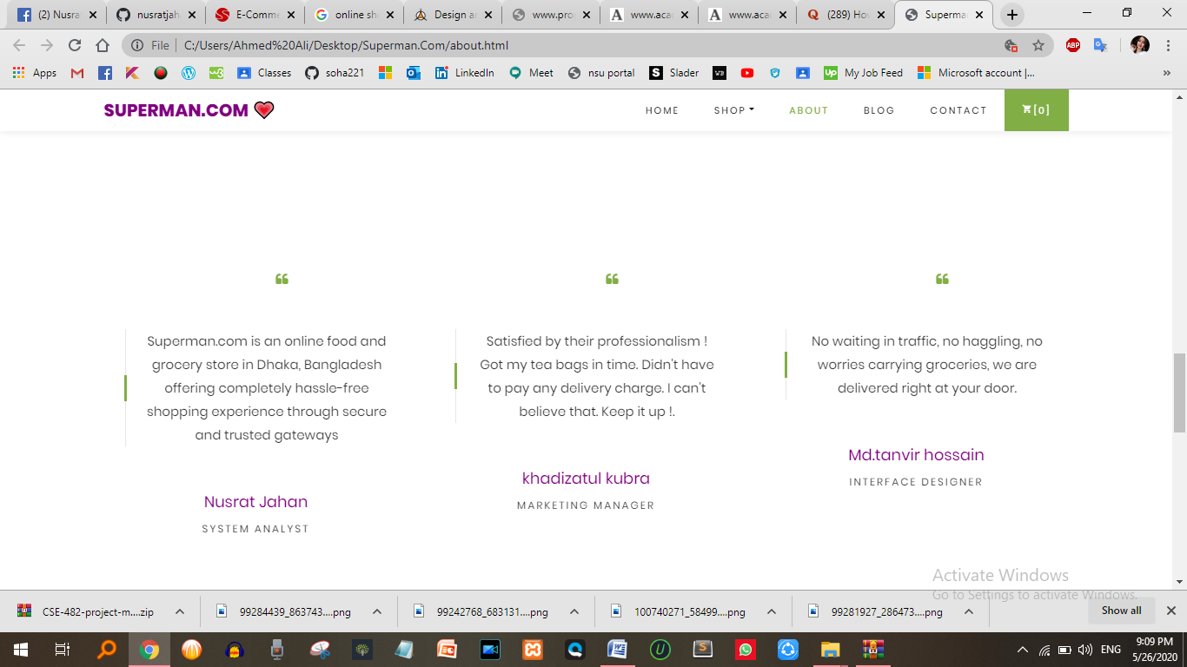

REGISTER PAGE: New users can register here.



LOGIN PAGE: Login page for both users and administrations.



ORDER VIEW FOR USER: Once users order item they are able to see ordered products and grand total.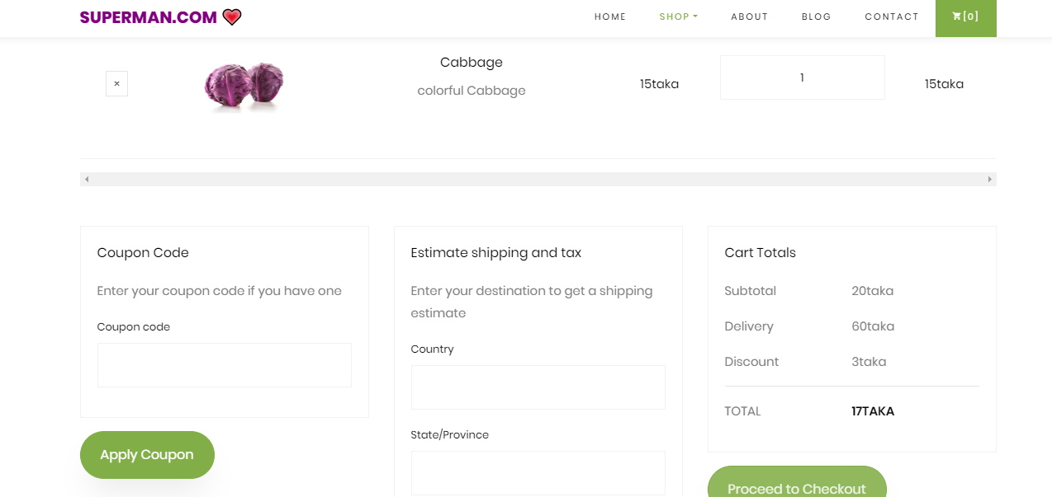

BILLING METHOD FOR PAYMENT: Once user orders products they are redirected to payment page.

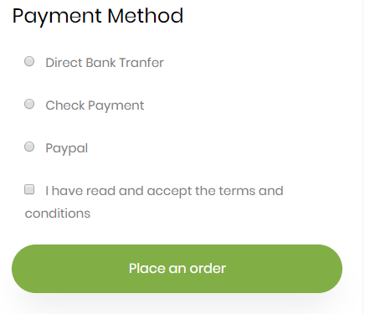

Testimony Page:

User can left a comment and review about our service on our page.

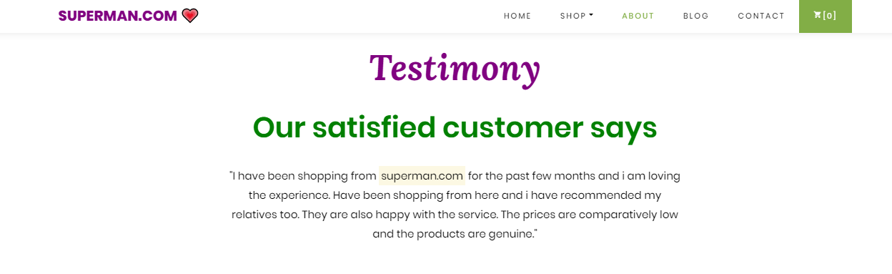

Blog Page:

Different news and personal experience of food bloggers are also attached. User can comment on blogs.

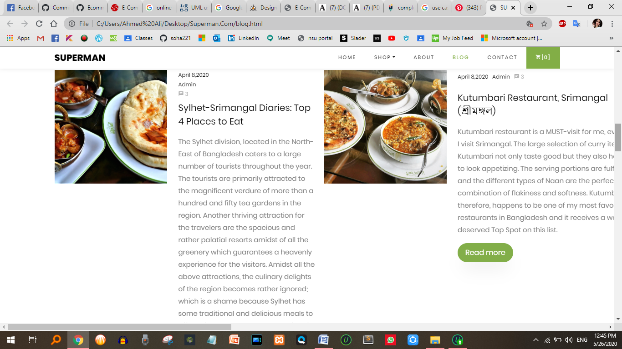

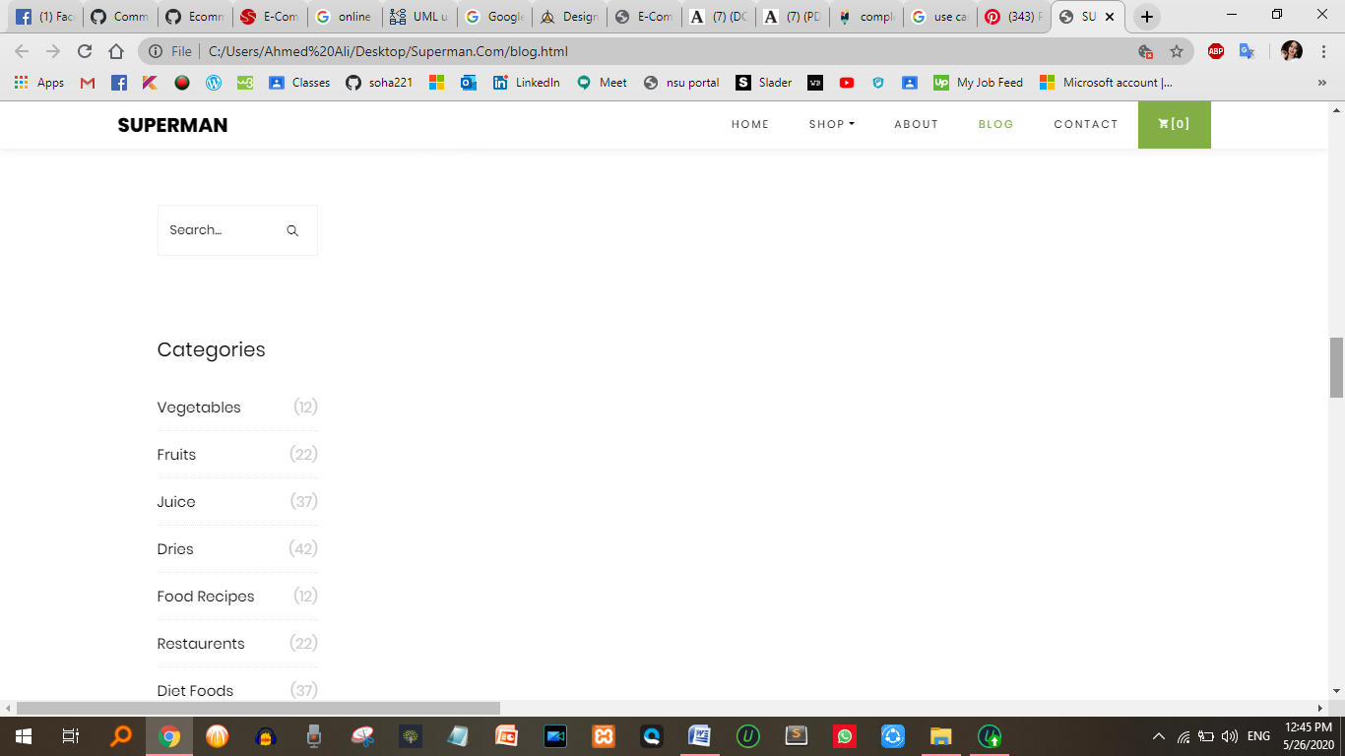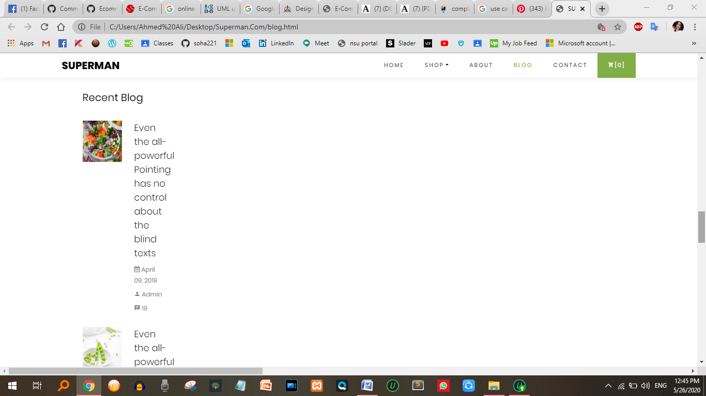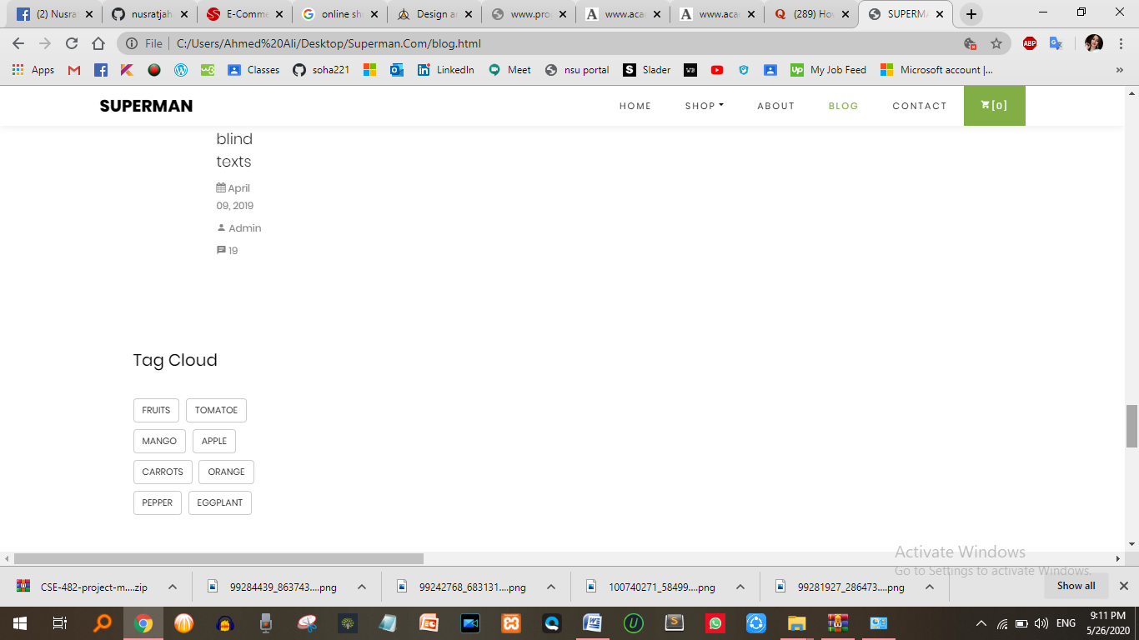

Other Features:

Others feature like subscription, monthly deal etc are also visible in our webpage.

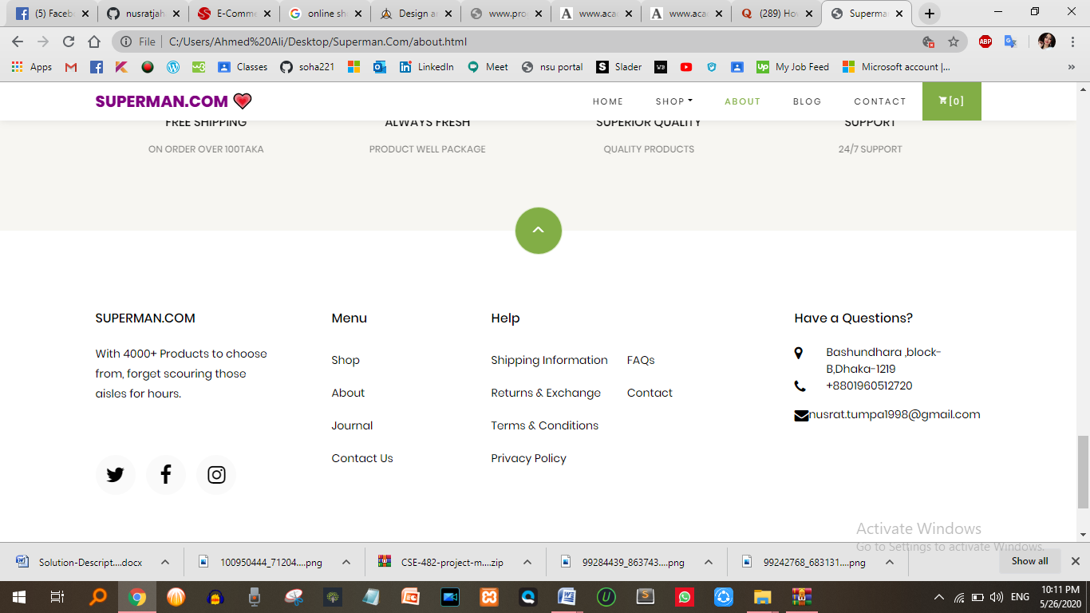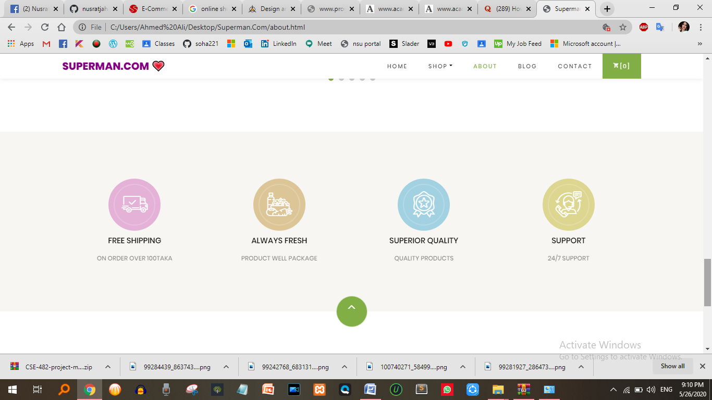

Data Description

This database consists of

¬ Users: User and Admin information is added to database with Unique ID based on their roles.

¬ Shopping: Complete products information is stored in this table.

¬ Orders: Customer ordered products, status and delivery information is stored in this table.

Data Objects

¬ User: ID, UserName, Password, Email, Gender, Role

¬ Shopping: ID, Product, Product ID, Cost, Category, Image, Description

¬ Orders: ID, Client, Product, Quantity, Price, Date, OrderShipped, Address

## Database Table Diagram:

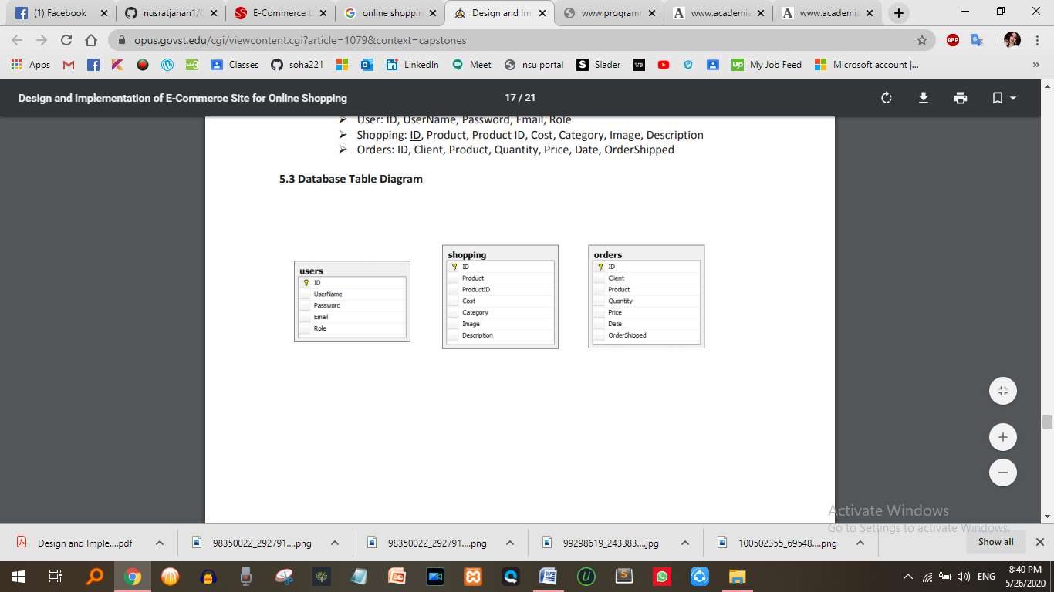

Limitations:

1. No One Can Buy During a Site Crash
2. Delivery boy shortage
3. High Labor cost
4. Technical limitations
5. Delivery Time Problem
6. Customer proper info missing

Security

¬ Pages of the website must be access in the way they were intended to be accessed. Included files shall not be accessed outside of their parent file.

¬ Administrator can only perform administrative task on pages they are privileged to access. Customers will not be allowed to access the administrator pages.

Efficiency and Maintainability

¬ Page loads should be returned and formatted in time depending on the request being made.

¬ Administrators will have the ability to edit the aspects of the order forms, product descriptions, prices and website directly

**Project Schedule:**

The whole system is expected to be delivered by three months with weekly evaluation by the project guide.

**Conclusion:**

The Internet has become a major resource in modern business, thus online shopping has gained significance not only from the entrepreneur’s but also from the customer’s point of view. For the entrepreneur, online shopping generates new business opportunities and for the customer, it makes comparative shopping possible. As per a survey, most consumers of online stores are impulsive and usually make a decision to stay on a site within the first few seconds. “Website design is like a shop interior. If the shop looks poor or like hundreds of other shops the customer is most likely to skip to the other site. Hence we have designed the project to provide the user with easy navigation, retrieval of data and necessary feedback as much as possible. In this project, the user is provided with an ecommerce web site that can be used to buy grocery item online. To implement this as a web application we used HTML, CSS, BOOTSTRAP, JS, PHP, and DATABASE. This project has several advantages such as enhanced performance, scalability, built-in security and simplicity.

# Reference:

1. <https://www.w3schools.com/>
2. <http://csharp-video-tutorials.blogspot.co.uk/p/free-dot-net-video-tutorials-for.html>
3. <http://csharp-video-tutorials.blogspot.com/p/free-aspnet-video-tutorial.html>
4. <https://creately.com/>
5. <https://opus.govst.edu/cgi/viewcontent.cgi?article=1079&context=capstones>
6. <https://themeforest.net/category/ecommerce>